Literacy support worksheet

8.1 Earth’s gravity pulls objects to the centre of the Earth

Pages 144–145 and 210

Gravity

1 Gravity is a force that attracts an object to the centre of the Earth. What is a gravitational field?

Isaac Newton is pictured below on the day he first pondered the idea of gravity.

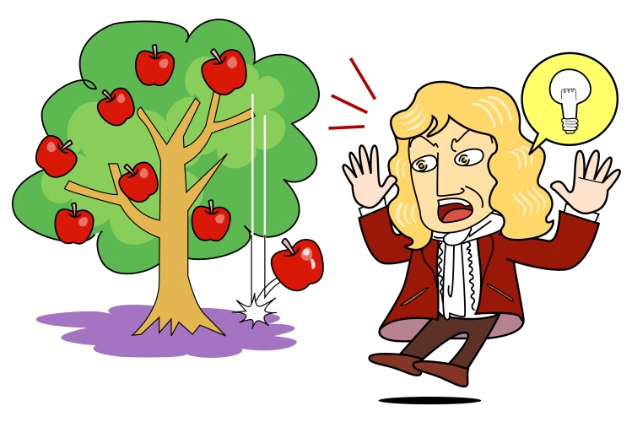2 Explain why the apple fell to the ground.

3 An apple has a mass of 200 grams (0.2 kg).

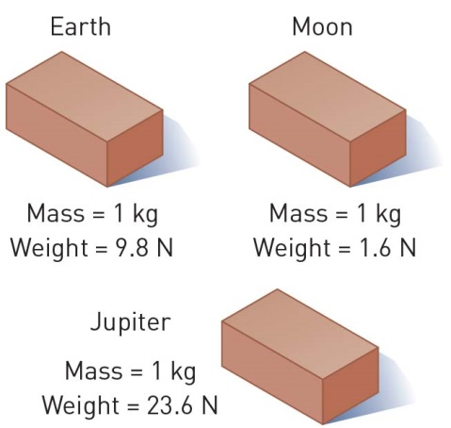 On Earth, the apple’s weight would be:

0.2 kg × 9.8 N = 1.96 N.

Using the diagram of the bricks as a guide, calculate what the apple’s weight would be on:

a the Moon: ___________________________________

b Jupiter: _____________________________________

4 Assume Newton’s mass was about 60 kilograms.

On Earth, his weight would be:

60 kg x 9.8N = 588N

What would his weight be on:

a the Moon? ______________________________________

b Jupiter? ________________________________________

5 Draw a labelled diagram to explain why a tennis ball and a cricket ball would both fall at the same speed when dropped from the same height. Refer to Figure 8.5 to help you.

|  |
| --- |
|  |

WORD DETECTIVE

6 Fill in the gaps

Fill in the gaps using the words listed below.

gravity force gravitational weight pull astronauts matter mass

Gravity is a non-contact ______________that we experience every day. Isaac Newton was the first person to describe ______________ as a force that attracts an object to the centre of the Earth. The Earth is made up of enormous amounts of ______________. The greater the amount of matter, the greater the ______________ pull.

The moon’s gravitational pull is much less than the Earth’s. This is why ______________ are able to jump much higher on the moon than on the Earth.

______________ is a measure of how much gravity pulls on an object. The amount of matter or particles in an object is described as the ____________. Even though some objects weigh more and have a greater gravitational ______________, if two objects are dropped at the same height and the same time, they will fall to Earth at the same time.

Literacy support worksheet

8.2 Gravity keeps planets in orbit around the Sun

Pages 146–147 and 211

Gravitational orbit

1 What theory existed before the scientist Galileo Galilei showed that the Earth orbited the Sun?

2 Using Figure 8.9 on page 147 of the textbook, describe in your own words how the Moon stays in orbit around the Earth.

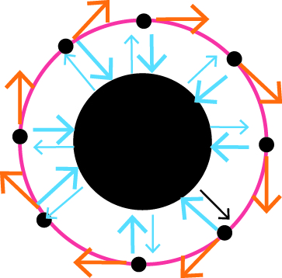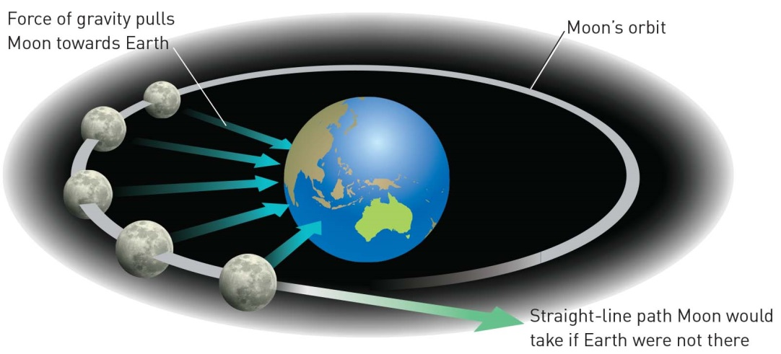

3 The Moon moves away from the Earth by approximately 3.7 cm per year. How far has it moved:

a since you were born? _________________________________________________

b since either of your parents was born? ____________________________________

c since any of your grandparents were born? _________________________________

WORD DETECTIVE

4 Secret message

Use words from the student book to work out the secret message below:

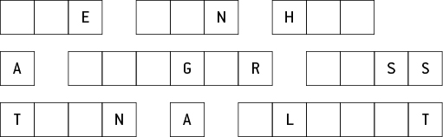

Literacy support worksheet

8.3 The Moon’s gravity causes tidal movements

Pages 148–149

Tidal movement

1 Fill in the boxes to explain the creation of tides (the orange bulge represents the Moon’s gravitational pull and the yellow bulge represents the Sun’s gravitational pull).

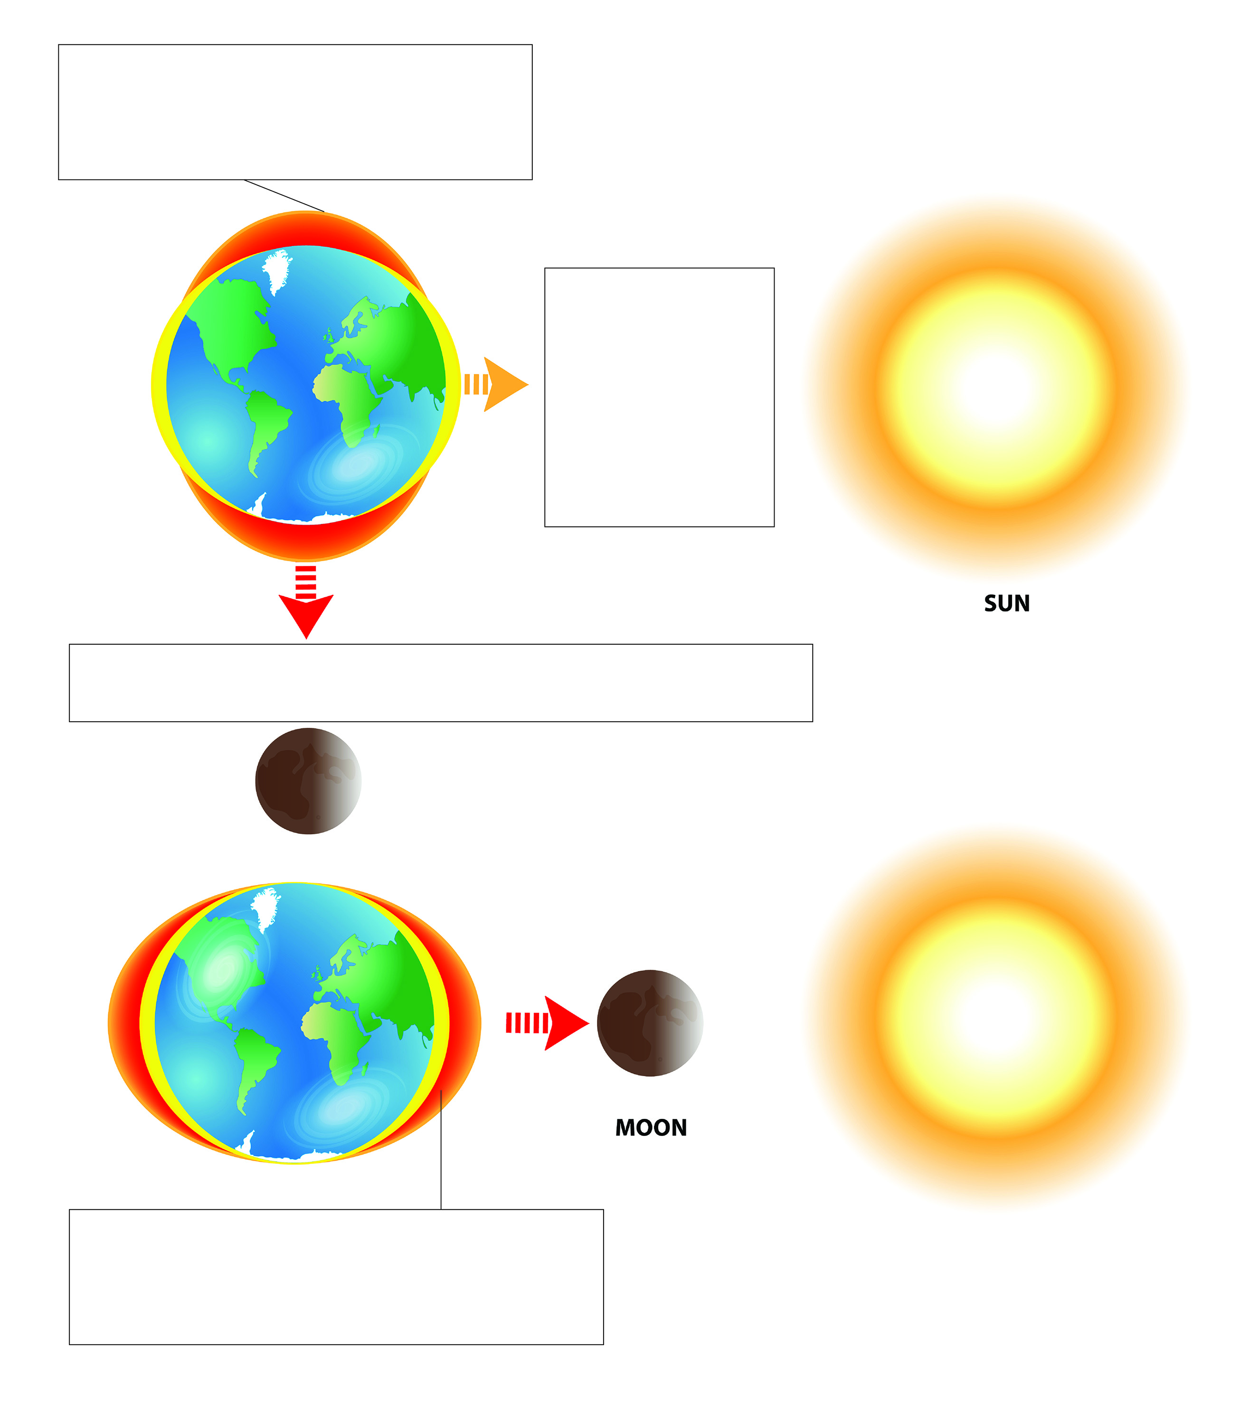

2 The Sun is 400 times further away from the Earth than the Moon, so the Moon has a greater effect on tides even though the Sun is much bigger.

The facts are:

• the mass of the Sun is 27 million times greater than that of the Moon

• the force of the Moon on the tides is 59 million times greater than that of the Sun.

Work out the difference in the tide-causing force using the formula below.



= ___________ × 100

= ___________%

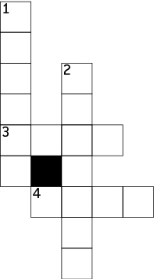WORD DETECTIVE

3 Crossword

Use the clues to fill in the crossword.

**Across**

3 A smaller tide when the Sun and moon are at right angles

4 The rise and fall in water levels on the seashore twice a day

**Down**

1 Very high and very low tides when the Sun, Moon and Earth are all in a line

2 Attracts objects to one another

Literacy support worksheet

8.4 Scientists work collaboratively to explore microgravity

Pages 150–151

Microgravity

1 Write two interesting facts about the International Space Station.

2 Label the picture with some of the effects of microgravity on an astronaut.

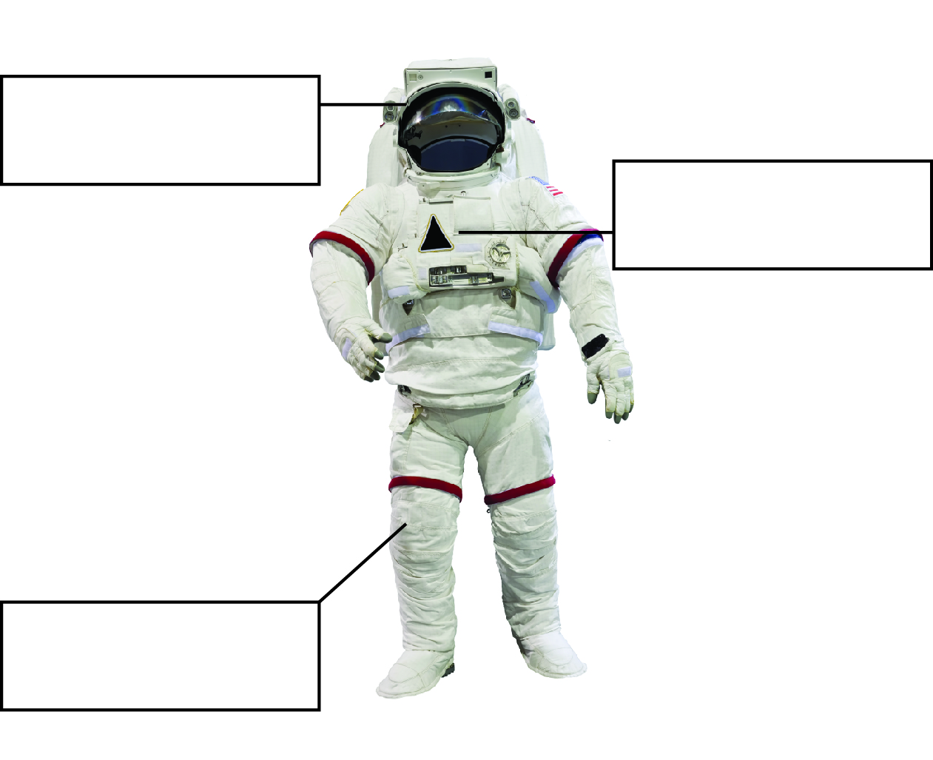

WORD DETECTIVE

3 True or false

Read each statement below and circle T if it is true or F if it is false.

a The ISS stands for the International Space Station T or F

b Microgravity is large amounts of gravity T or F

c Weight is measured in newtons in space T or F

d Astronauts easily break bones after returning to Earth T or F

e There is no possibility that we will live on Mars one day T or F

f The space station is falling towards the Earth T or F